Chapter 10, Solution 37.

I₁

+ I_{x}
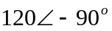V Z
- I₂ Z=80-j35

I_{z}
- I_{y}
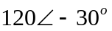V Z
+ I₃

For mesh x,

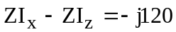 (1)
For mesh y,

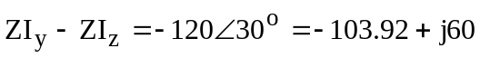 (2)

For mesh z,

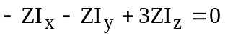 (3)

Putting (1) to (3) together leads to the following matrix equation:

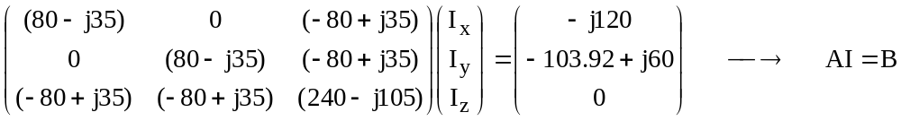

Using MATLAB, we obtain

